**PLAYER**

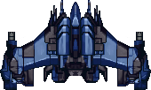

The player can move left and right with the arrow keys.

The player cannot move out of the game area.

The player will be locked to the bottom of the game area.

The player can shoot a projectile forward with the space bar.

The projectile will be from the middle front of the ship.

Optional: Upgrade to allow two projectiles from the sides of the ship instead.

When the player is hit, it will lose 100 points from the total score.

Optional: The player will flash and be invulnerable for 3 seconds following the hit.

**ENEMY**

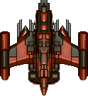 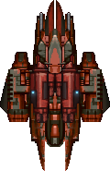 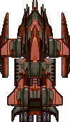 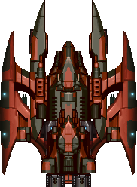 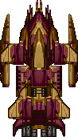

The enemy will spawn off of the screen at the top.

Enemy 1 will travel down towards the player in a linear fashion.

The projectile will be from the middle front of the ship.

Base health will be 1.

Enemy 2 will travel down towards the player in a linear fashion.

There will be two projectiles from the sides of the ship

Base health will be 1.

Enemy 3 will travel down towards the player in a linear fashion.

The projectile will be from the middle front of the ship.

This will also be a homing missile towards the players LAST location.

Base health will be 2.

Enemy 4 will travel until it is completely displayed at the top of the game area.

It will move left and right at the top of the screen for 5 seconds.

It will then continue in a linear fashion towards the player.

The projectile will be from the middle front of the ship.

Base health will be 2.

Enemy 5 will travel down towards the player in a linear fashion.

The projectile will be from the middle front of the ship.

Base health will be 3.

When destroyed, the player will be rewarded with 100 points.

The enemies will also have an increasing chance to drop an answer as time goes on.

**BOSS**

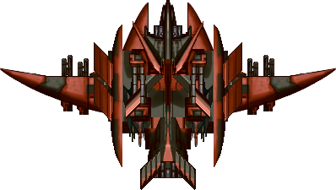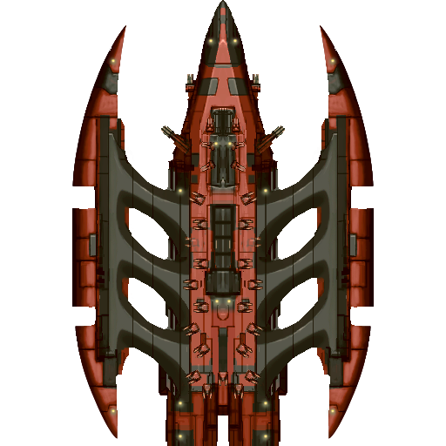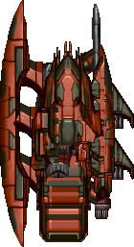 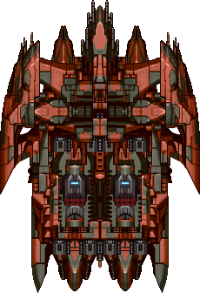

Bosses act differently to normal ships. They do not fire any projectiles.

Bosses remain at the top of the screen and are divided up into sections (2 – 4)

Each part will contain an answer to the question displayed on the screen.

Selecting the wrong answer costs the player 200 points.

Selecting the right answer will disable that part of the ship.

The boss is defeated when all parts have been disabled.

Each boss will appear after 10 waves has been completed.

Defeating the boss as quickly as possible will provide a time-based reward of up to 5000.

**BACKGROUND**

The background will consist of a starry image and will scroll downward to create the illusion of movement.

Optional: Use the parallax technique to achieve this.

**UI**

The screen will be comprised of 4 main elements.

The Question Screen will be in the top left.

This will display a warning message to let the player know a question is inbound.

The question will be displayed clearly here for the duration of the boss fight.

The Information Screen will be in the bottom left.

This will display useful information concerning gameplay.

It will also contain programming trivia that includes answers to upcoming questions.

The Answer Screen will be on the right side.

This will contain the list of collected answers.

When an answer has been used, it will disappear/stricken-through/change colour.

The Game Screen.

This will contain the playable area.

**TEXT**

The text needs to be easily readable on a dark background. The preferable typeface is Courier.

**SOUND**

Optional.

**MISCELLANIOUS**

